**Assignment 2**

**Due**: November 17, 2023

1. Which Gestalt principles are being used in the Figure 1? Where and how? What effect does each achieve?

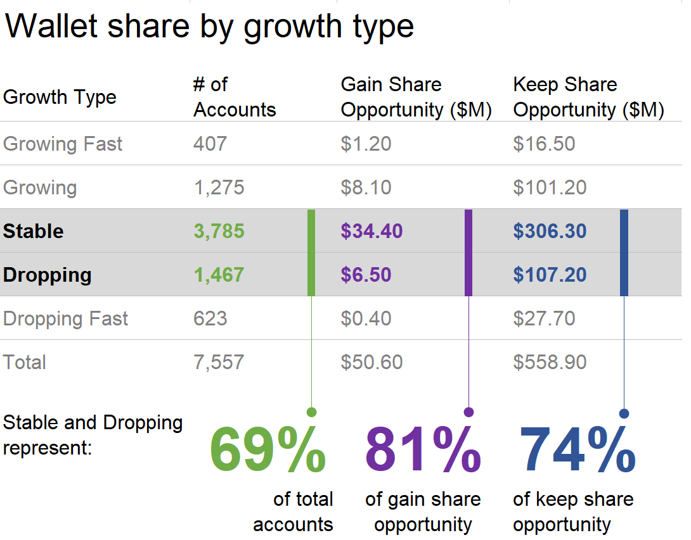

**Figure 1**

1. Alignment and white space are elements of the visual design, that when done well, we don’t even notice. However when they aren’t done well, we feel it in the resulting visual. It may seem disorganized or connote lack of attention to detail, distracting from our data and message.

Consider Figure 2, which shows consumer sentiment based on survey results  
about various potential beverage line extensions for a food manufacturing company.

(a) Reflect on what specific changes you would recommend when it comes  
to the effective use of alignment and white space. List them.  
(b) What other steps would you take to declutter or otherwise improve this visual?  
(c) Use the data in problem_2.xlsx and make the changes you’ve recommended to the existing graph, or import the data into your preferred tool and create a clutter-free visual that aligns elements and makes use of white space.

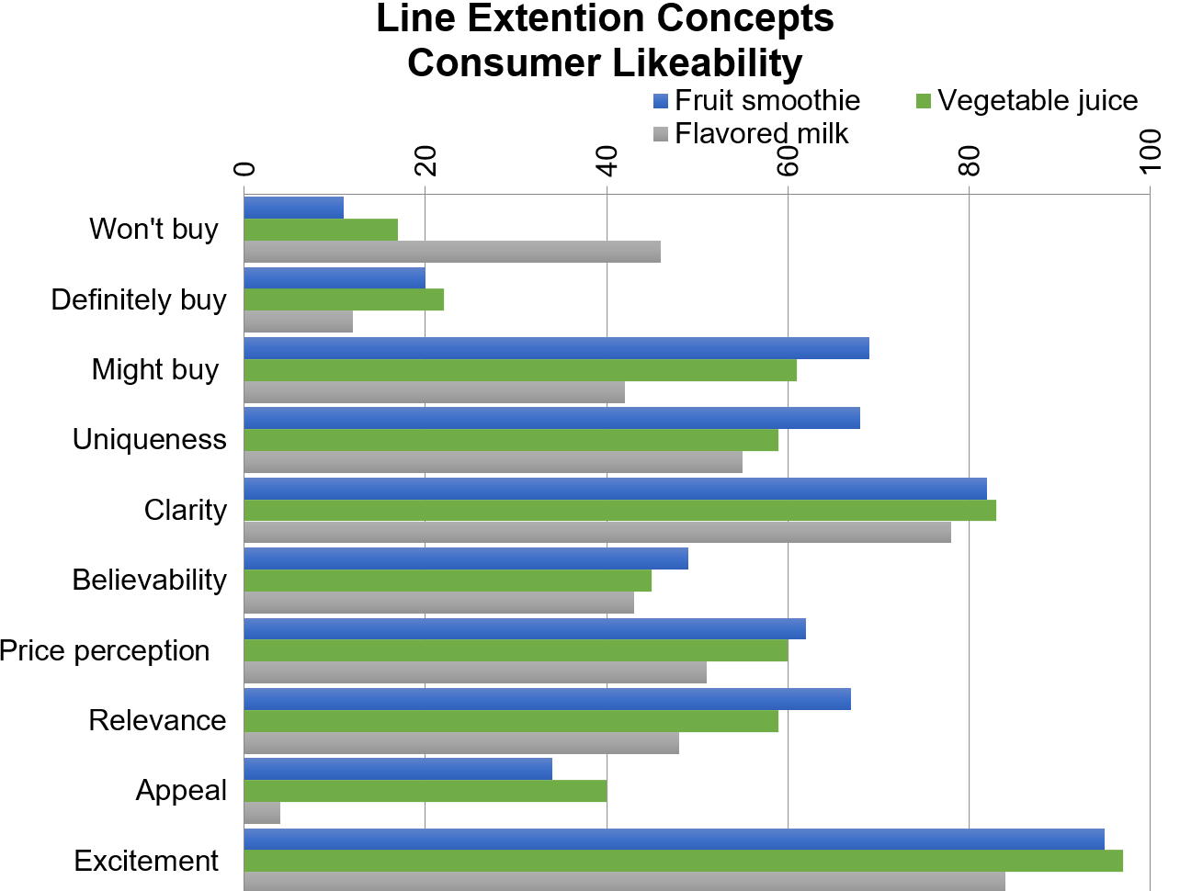

**Figure 2**

1. Consider Figure 3, which shows customer satisfaction score over time. What  
   unnecessary visual elements could you eliminate? What other changes would  
   you make to reduce cognitive burden? Make some notes about the changes you would make to declutter this graph.

Use the data in problem_3.xlsx and make the changes you’ve recommended to the existing graph, or import the data into your preferred tool and  
create a visual that is clutter-free.

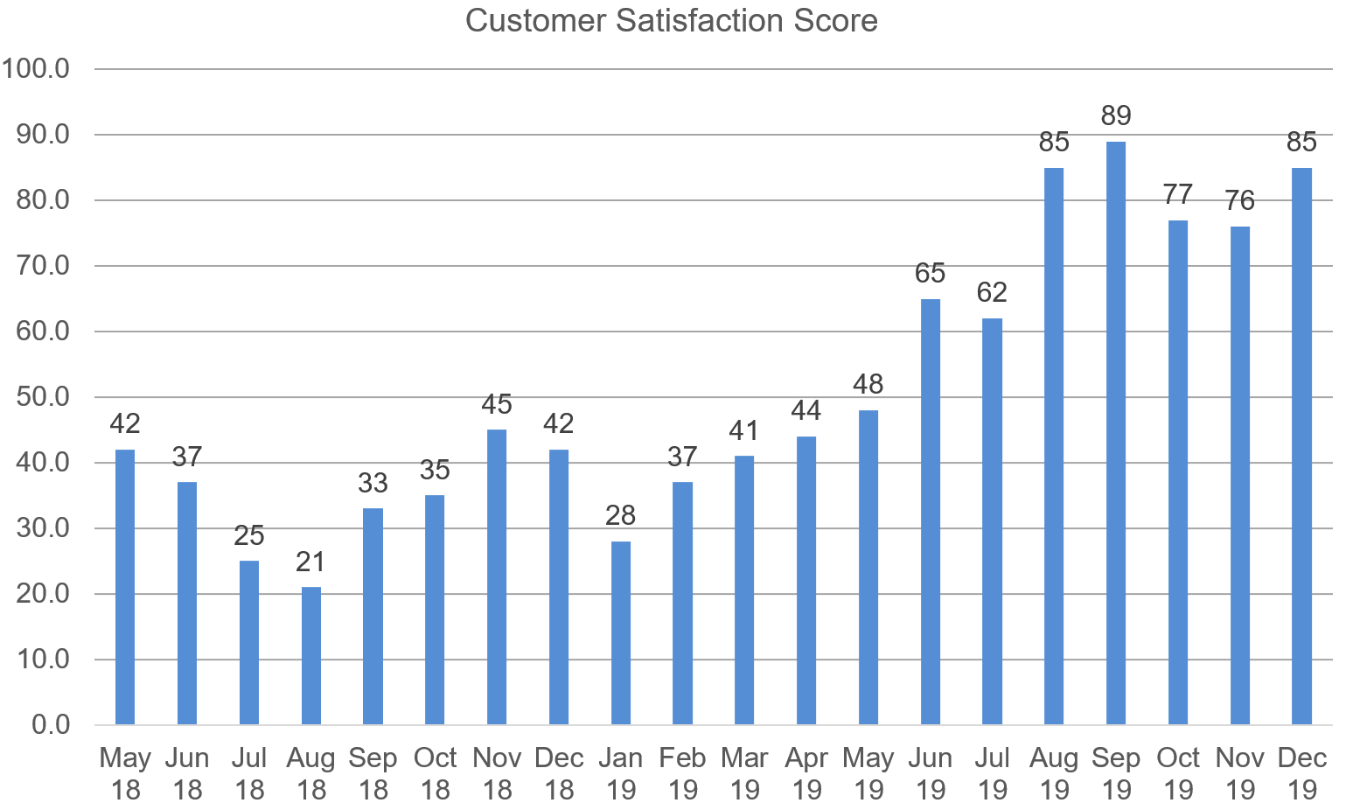

**Figure 3**

1. Check out Figure 4, which shows the monthly number of cars sold by a national chain of dealerships. What unnecessary visual elements could you eliminate? What other changes would you make to reduce cognitive burden? Make some notes about the changes you would make to declutter this graph.

Use the data in problem_4.xlsx and make the changes you’ve recommended to the existing graph, or import the data into your preferred tool and create a visual that is clutter-free.

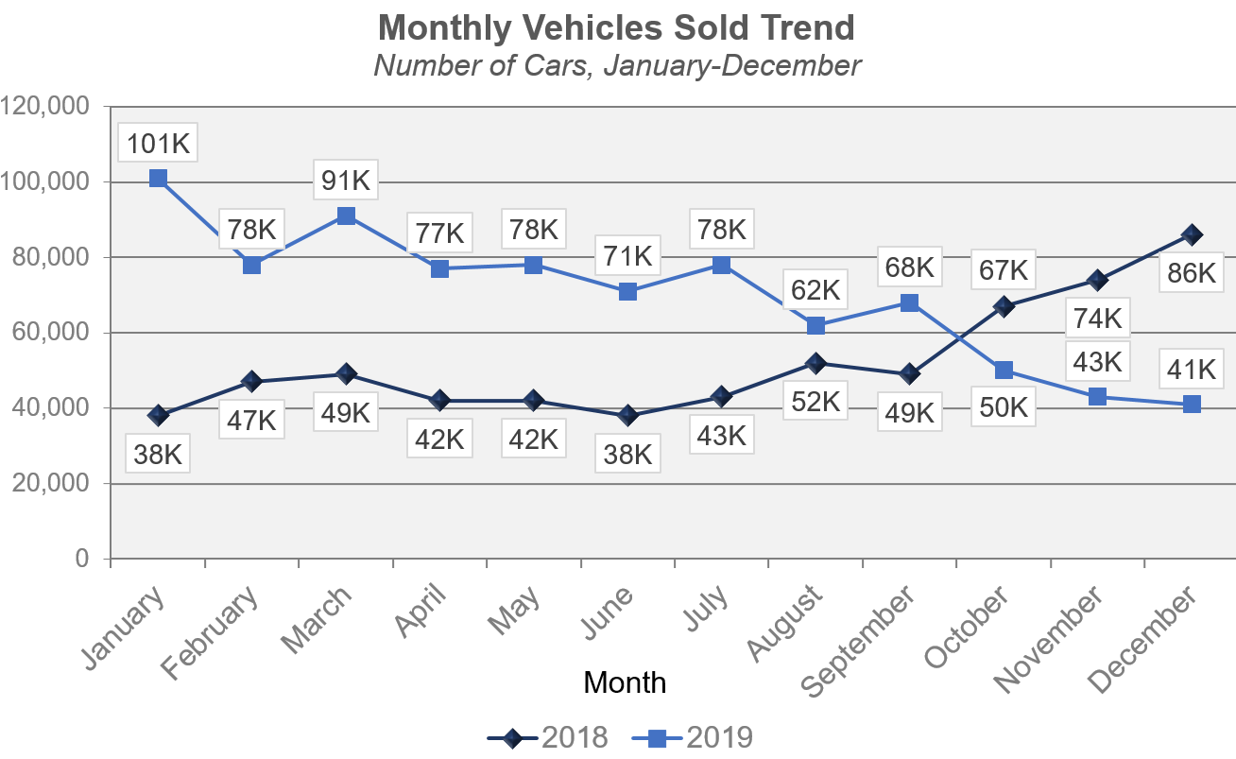

**Figure 4**

1. See Figure 5, which shows the percent of customers of a given bank having automated payments by different products. What unnecessary visual elements could you eliminate? What other changes would you make to reduce cognitive burden? Make some notes about the changes you would make to declutter this graph.  
   Use the data in problem_5.xlsx and make the changes you’ve recommended to the existing graph, or import the data into your preferred tool and  
   create a visual that is clutter-free

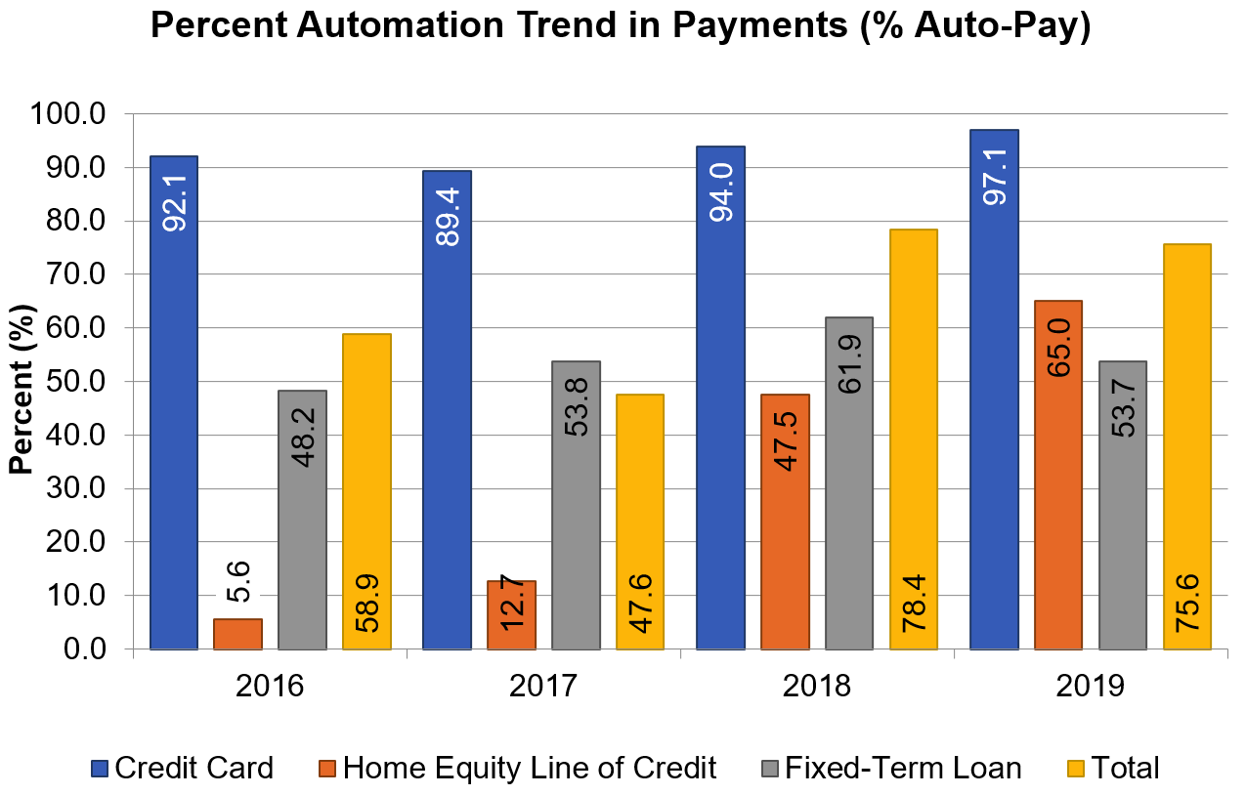

**Figure 5**